**Macro Photography:**

**Macro photography** (or **photomicrography**or **macrography**, and sometimes **macrophotography**) is extreme [close-up](https://en.wikipedia.org/wiki/Close-up) photography, usually of very small subjects and living organisms like insects, in which the size of the subject in the photograph is greater than life size (though *macrophotography* also refers to the art of making very large photographs).By the original definition, a macro photograph is one in which the size of the subject on the [negative](https://en.wikipedia.org/wiki/Negative_(photography)) or [image sensor](https://en.wikipedia.org/wiki/Image_sensor) is life size or greater.In some senses, however, it refers to a finished photograph of a subject that is greater than life size.

**Technical Considerations:**

**Depth of field:**

Limited [depth of field](https://en.wikipedia.org/wiki/Depth_of_field) is an important consideration in macro photography. Depth of field is extremely small when focusing on close objects. A small [aperture](https://en.wikipedia.org/wiki/Aperture) (high [f-number](https://en.wikipedia.org/wiki/F-number)) is often required to produce acceptable sharpness across a three-dimensional subject. This requires either a slow shutter speed, brilliant lighting, or a high ISO. Auxiliary lighting (such as from a [flash unit](https://en.wikipedia.org/wiki/Flash_(photography))), preferably a [ring flash](https://en.wikipedia.org/wiki/Ring_flash) is often used . Like conventional lenses, macro lenses need light, and ideally would provide similar *f*/# to conventional lenses to provide similar exposure times. Macro lenses also have similar focal lengths, so the [entrance pupil](https://en.wikipedia.org/wiki/Entrance_pupil) diameter is comparable to that of conventional lenses (e.g., a 100 mm *f*/2.8 lens has a 100 mm/2.8 = 35.7 mm entrance-pupil diameter). Because they focus at close subjects, the cone of light from a subject point to the entrance pupil is relatively obtuse (a relatively high subject [numerical aperture](https://en.wikipedia.org/wiki/Numerical_aperture), to use a microscopy term), making the [depth of field](https://en.wikipedia.org/wiki/Depth_of_field) extraordinarily small. This makes it essential to [focus](https://en.wikipedia.org/wiki/Focus_(optics)) critically on the most important part of the subject, as elements that are even a millimetre closer or farther from the focal plane might be noticeably blurred. Due to this, the use of a microscope stage is highly recommended for precise focus with large magnification, for example when photographing skin cells. Alternatively, more shots of the same subject can be made with slightly different focusing lengths and joined afterwards with specialized [focus stacking](https://en.wikipedia.org/wiki/Focus_stacking) software which picks out the sharpest parts of every image, artificially increasing the perceived depth of field of the resulting image.

### Lighting:

The problem of sufficiently and evenly lighting the subject can be difficult to overcome. Some cameras can focus on subjects so close that they touch the front of the lens. It is difficult to place a light between the camera and a subject that close, making extreme close-up photography impractical. A normal-focal-length macro lens (50 mm on a 35 mm camera) can focus so close that lighting remains difficult. To avoid this problem, many photographers use [telephoto](https://en.wikipedia.org/wiki/Telephoto_lens) macro lenses, typically with focal lengths from about 100 to 200 mm. These are popular as they permit sufficient distance for lighting between the camera and the subject.

[Ring flashes](https://en.wikipedia.org/wiki/Ring_flash), with flash tubes arranged in a circle around the front of the lens, can be helpful in lighting at close distances. Ring lights have emerged, using white [LEDs](https://en.wikipedia.org/wiki/Light-emitting_diode) to provide a continuous light source for macro photography, however they are not as bright as a ring flash and the white balance is very cool.

Good results can also be obtained by using a [flash diffuser](https://en.wikipedia.org/wiki/Flash_diffuser). Homemade flash diffusers made out of white Styrofoam or plastic attached to a camera's built-in flash can also yield surprisingly good results by diffusing and softening the light, eliminating [specular reflections](https://en.wikipedia.org/wiki/Specular_reflection) and providing more even lighting.

### Chromatic aberration:

Many macro lenses are characterised by a high amount of [chromatic aberration](https://en.wikipedia.org/wiki/Chromatic_aberration), especially when using reversed-lens, extension tube or close-up lens. Some macro lenses, called [apochromatic lenses](https://en.wikipedia.org/wiki/Apochromat), are designed to better control this, such as the Laowa 100mm f/2.8 2x Ultra Macro APO and the Sigma APO MACRO 150mm F2.8.

**Macro Photography Image**

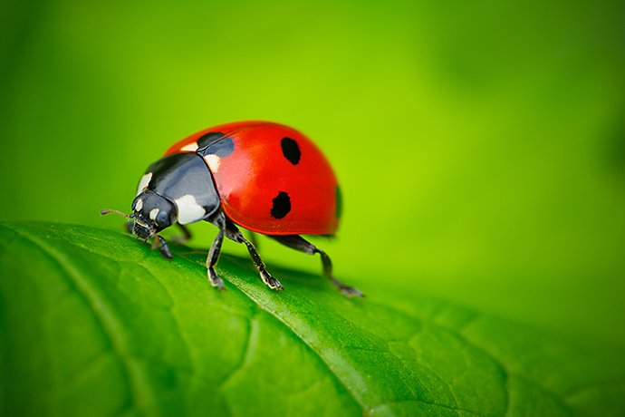

**Food Photography:**

**Food photography** is a [still life photography](https://en.wikipedia.org/wiki/Still_life_photography) genre used to create attractive [still life](https://en.wikipedia.org/wiki/Still_life) photographs of [food](https://en.wikipedia.org/wiki/Food). As a specialization of [commercial photography](https://en.wikipedia.org/wiki/Commercial_photography), its output is used in advertisements, magazines, packaging, menus or cookbooks. Professional food photography is a collaborative effort, usually involving an [art director](https://en.wikipedia.org/wiki/Art_director), a [photographer](https://en.wikipedia.org/wiki/Photographer), a food stylist, a [prop](https://en.wikipedia.org/wiki/Theatrical_property) stylist and their assistants.With the advent of [social media](https://en.wikipedia.org/wiki/Social_media), amateur food photography has gained popularity among restaurant diners.

In advertising, food photography is often – and sometimes controversially – used to exaggerate the attractiveness or size of the advertised food, notably [fast food](https://en.wikipedia.org/wiki/Fast_food).

**History:**

The first known photograph that showed food as a subject was a 1845 [daguerreotype](https://en.wikipedia.org/wiki/Daguerreotype) by [William Henry Fox Talbot](https://en.wikipedia.org/wiki/William_Henry_Fox_Talbot) showing peaches and a pineapple.

For a long time, food photographs tended to be shot and composed in a manner similar to the way people were used to encountering their food: laid out on a table setting and shot from an overhead perspective, i.e., from the point of view of the eater.Stylists accordingly arranged the food to appear good from above, with the items arranged flat on the plate and clearly separated from each other.

Later, romantic lighting, shallower angles and more props came *en vogue*,with extreme cases leading to the term "[food porn](https://en.wikipedia.org/wiki/Food_porn)". Most recently, the prevailing trend in Western commercial food photography is to present the food as simple, clean and naturally as possible and with little props, often using effects such as selective [focus](https://en.wikipedia.org/wiki/Focus_(optics)), tilted plates, and extreme [close-ups](https://en.wikipedia.org/wiki/Close-up).This complements trends in professional cooking to make the food more visually interesting. For instance, the height of dishes tends to increase and their elements are often layered, which lends itself well to narrow-angled shots

**Food Photography Image**



**Sports Photography:**

**Sports photography** refers to the genre of [photography](https://en.wikipedia.org/wiki/Photography) that covers all types of [sports](https://en.wikipedia.org/wiki/Sport).

In the majority of cases, professional sports photography is a branch of [photojournalism](https://en.wikipedia.org/wiki/Photojournalism)*,* while amateur sports photography, such as photos of children playing [association football](https://en.wikipedia.org/wiki/Association_football), is a branch of [vernacular photography](https://en.wikipedia.org/wiki/Vernacular_photography)*.*

The main application of professional sports photography is for editorial purposes; dedicated sports photographers usually work for newspapers, major wire agencies or dedicated sports magazines. However, sports photography is also used for advertising purposes both to build a brand and as well as to promote a sport in a way that cannot be accomplished by editorial means.

**Technique:**

In order to minimize motion blur of moving subjects, the light sensitivity ("ISO" value) is increased, which shortens the necessary exposure time to capture sufficient light. The trade-off of increasing light sensitivity is increased noise, so sports photography is most effective in daylight and with higher-end cameras that are equipped with larger image sensors that capture more light and support higher light sensitivities.

Location is often important for sports photography. At big events, professional photographers often shoot from VIP spots with the best views, usually as close to the action as possible. Most sports require the photographer to frame their images with speed and adjust camera settings spontaneously to prevent blurring or incorrect exposure. Some sports photography is also done from a distance to give the game a unique effect.

Getting to know your subjects is critical in capturing emotion. Effects and editing can only do so much for a photo. Understanding who athletes are by having a conversation with them can change your view on the person, making you a better photographer.

**Sports Photography Image**

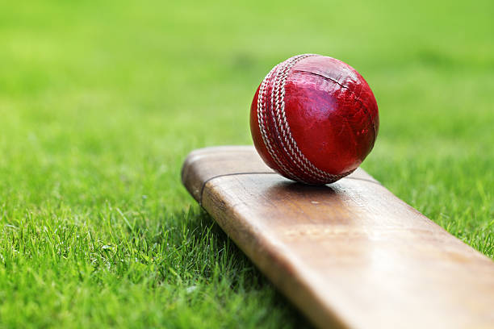

**Astrophotography:**

**Astrophotography**, also known as astronomical imaging, is the [photography](https://en.wikipedia.org/wiki/Photography) or [imaging](https://en.wikipedia.org/wiki/Imaging) of [astronomical objects](https://en.wikipedia.org/wiki/Astronomical_object), celestial events, or areas of the [night sky](https://en.wikipedia.org/wiki/Night_sky). The first photograph of an astronomical object (the [Moon](https://en.wikipedia.org/wiki/Moon)) was taken in 1840, but it was not until the late 19th century that advances in technology allowed for detailed stellar photography. Besides being able to record the details of extended objects such as the [Moon](https://en.wikipedia.org/wiki/Moon), [Sun](https://en.wikipedia.org/wiki/Sun), and [planets](https://en.wikipedia.org/wiki/Planet), modern astrophotography has the ability to image objects outside of the visible spectrum of the human eye such as dim [stars](https://en.wikipedia.org/wiki/Star), [nebulae](https://en.wikipedia.org/wiki/Nebula), and [galaxies](https://en.wikipedia.org/wiki/Galaxy). This is accomplished through [long time exposure](https://en.wikipedia.org/wiki/Long-exposure_photography) as both film and digital cameras can accumulate and sum [photons](https://en.wikipedia.org/wiki/Photon) over long periods of time or using specialized optical filters which limit the photons to a certain wavelength.

Photography using extended exposure-times revolutionized the field of professional astronomical research, recording hundreds of thousands of new stars, and nebulae invisible to the human eye. Specialized and ever-larger [optical telescopes](https://en.wikipedia.org/wiki/Optical_telescopes) were constructed as essentially big cameras to record images on [photographic plates](https://en.wikipedia.org/wiki/Photographic_plate). Astrophotography had an early role in sky surveys and star classification but over time it has used ever more sophisticated [image sensors](https://en.wikipedia.org/wiki/Image_sensor) and other equipment and techniques designed for specific fields.

Since almost all [observational astronomy](https://en.wikipedia.org/wiki/Observational_astronomy) today uses photography, the term "astrophotography" usually refers to its use in [amateur astronomy](https://en.wikipedia.org/wiki/Amateur_astronomy), seeking aesthetically pleasing images rather than scientific data. Amateurs use a wide range of special equipment and techniques.

**History:**

The development of astrophotography as a scientific tool was pioneered in the mid-19th century for the most part by experimenters and [amateur astronomers](https://en.wikipedia.org/wiki/Amateur_astronomers), or so-called "[gentleman scientists](https://en.wikipedia.org/wiki/Gentleman_scientist)" (although, as in other scientific fields, these were not always men). Because of the very long exposures needed to capture relatively faint astronomical objects, many technological problems had to be overcome. These included making telescopes rigid enough so they would not sag out of focus during the exposure, building clock drives that could rotate the telescope mount at a constant rate, and developing ways to accurately keep a telescope aimed at a fixed point over a long period of time. Early photographic processes also had limitations. The [daguerreotype](https://en.wikipedia.org/wiki/Daguerreotype) process was far too slow to record anything but the brightest objects, and the wet plate [collodion](https://en.wikipedia.org/wiki/Collodion" \o "Collodion) process limited exposures to the time the plate could stay wet.

The first known attempt at astronomical photography was by [Louis Jacques Mandé Daguerre](https://en.wikipedia.org/wiki/Louis_Jacques_Mand%C3%A9_Daguerre), inventor of the daguerreotype process which bears his name, who attempted in 1839 to photograph the [Moon](https://en.wikipedia.org/wiki/Moon). Tracking errors in guiding the telescope during the long exposure meant the photograph came out as an indistinct fuzzy spot. [John William Draper](https://en.wikipedia.org/wiki/John_William_Draper), New York University Professor of Chemistry, physician and scientific experimenter managed to make the first successful photograph of the moon a year later on March 23, 1840, taking a 20-minute-long [daguerreotype](https://en.wikipedia.org/wiki/Daguerreotype) image using a 5-inch (13 cm) [reflecting telescope](https://en.wikipedia.org/wiki/Reflecting_telescope).The Sun may have been first photographed in an 1845 daguerreotype by the French physicists [Léon Foucault](https://en.wikipedia.org/wiki/L%C3%A9on_Foucault) and [Hippolyte Fizeau](https://en.wikipedia.org/wiki/Hippolyte_Fizeau" \o "Hippolyte Fizeau).

**Amateur astrophotography:**

Astrophotography is a popular hobby among photographers and amateur astronomers. Techniques ranges from basic film and digital cameras on tripods up to methods and equipment geared toward advanced imaging. Amateur astronomers and [amateur telescope makers](https://en.wikipedia.org/wiki/Amateur_telescope_maker) also use homemade equipment and modified devices.

**Astrophotography Image**

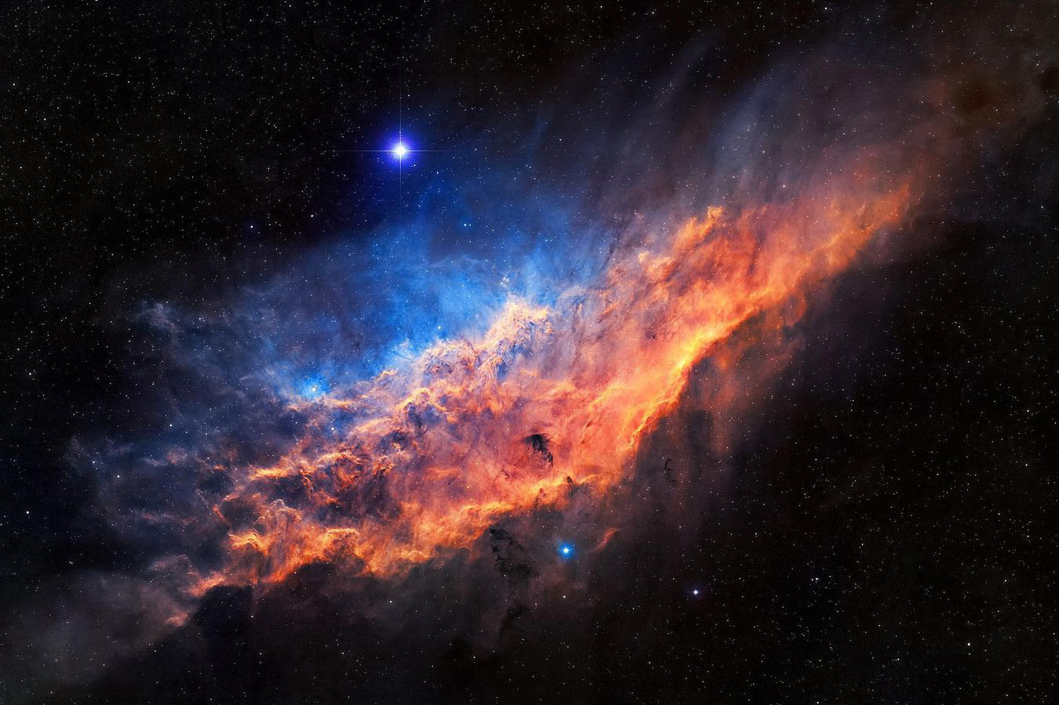

**Street Photography:**

**Street photography** (also sometimes called [candid photography](https://en.wikipedia.org/wiki/Candid_photography)) is [photography](https://en.wikipedia.org/wiki/Photography) conducted for art or inquiry that features unmediated chance encounters and random incidentswithin [public places](https://en.wikipedia.org/wiki/Public_space), usually with the aim of capturing images at a decisive or poignant moment by careful framing and timing. Although there is a difference between street and candid photography, it is usually subtle with most street photography being candid in nature and some candid photography being classifiable as street photography. Street photography does not necessitate the presence of a street or even the urban environment. Though people usually feature directly, street photography might be absent of people and can be of an object or environment where the image projects a decidedly human character in facsimile or aesthetic.

Street photography can focus on people and their behavior in public. In this respect, the street photographer is similar to [social documentary photographers](https://en.wikipedia.org/wiki/Social_documentary_photography) or [photojournalists](https://en.wikipedia.org/wiki/Photojournalism) who also work in public places, but with the aim of capturing newsworthy events. Any of these photographers' images may capture people and property visible within or from public places, which often entails navigating ethical issues and laws of privacy, security, and property.

Street photography is a vast genre that can be defined in many ways, but it is often characterized by the spontaneous capturing of an unrepeatable, fleeting moment, often of the everyday going-ons of strangers. It is classically shot with [wider angle lenses](https://en.wikipedia.org/wiki/Wide-angle_lens) (e.g. 35mm) and usually features urban environments.

### Street photography versus documentary photography:

Street photography and [documentary photography](https://en.wikipedia.org/wiki/Documentary_photography) are similar genres of photography that often overlap while having distinct individual qualities.Documentary photographers typically have a defined, premeditated message and an intention to record particular events in history.The gamut of the documentary approach encompasses aspects of journalism, art, education, sociology and history. Conversely, street photography is reactive and disinterested by natureand motivated by curiosity or creative inquiry,allowing it to deliver a relatively neutral depiction of the world that mirrors society, "unmanipulated" and with usually unaware subjects

### Candid street photography versus street portraits:

Street photography is generally seen as unposed and candid, but there are a few street photographers who interact with strangers on the streets and take their portraits. Street portraits are unplanned portraits taken of strangers while out doing street photography, however they are seen as posed because there is interaction with the subject.

**Street Photography Image**

